

MES Traceability Solution

Microtek International Pvt. Ltd.

Software Requirement Specification (SRS)
Project ID:
BAR CODE INDIA, 145 Udyog Vihar Phase 1, Gurugram, Haryana-122016, PH: 0124 4337555

Prepared By: Leena
Submission Date:
Version: 1.0
The document details the summary of solution architecture and approach for the development of MES Traceability Solution for Microtek International Pvt. Ltd. The document is based on the inputs, system study, discussions and meeting held between BCI & Microtek International Pvt. Ltd Teams.

REVISION NO. | DATE | PREPARED BY | REVIEWED BY | COMMENT
1.0.0 | 1 | Prateeksha and Leena | Ashutosh Kroria | Software Requirement Specification Document on basis of detailed process discussion with Microtek.

Abbreviations Used:

Abbreviations:
Name | Abbreviation
Microtek International Pvt. Ltd. | Microtek
Bar Code India | BCI
Fixed Mount Scanner | FMS
Handheld Terminal | HHT
Systems, Applications & Products in Data Processing | SAP

Masters

Material Master
Module Description | The module will be used to save the Material details in database. Material details are fetched from SAP.

Data Fields | - Material Code  - Description  - QA Status – Accepted/Rejected  - Material Type-RM,SF,CON TOL,MTS, SPR, SCP, PSD, ESD, HSD  - Purchase packing  - UOM  - Manufacturing Date  - Expiry Date  - Pack Size  - Conversion Factor

Process Steps | - Material Master screen will be visible to authorized personnel only  - BCI application will download Material master data from SAP  - Downloaded Material Master details will get displayed in data grid on screen  - Material data such as code, description, QA status, Material type, purchase packing UOM, Shelf life, pack size, conversion factor will be displayed from the downloaded data.

Functions | View details of the Material master.

Customer Master
Module Description | The module will be used to save the Customer details in database. Material details are fetched from SAP.

Data Fields | - Customer Code  - Name  - Address  - Contact No.  - Email

Process Steps | - Customer Master screen will be visible to authorized personnel only.  - BCI application will download Customer Master data from SAP.  - Downloaded Customer Master details such as Customer Code, Name will get displayed in data grid on screen.

Functions | View details of the Customer master.

Vendor Master
Module Description | The module will be used to save the Vendor details in database. Material details are fetched from SAP.

Data Fields | - Vendor Code  - Name

Process Steps | - Vendor Master screen will be visible to authorized personnel only.  - BCI application will download Vendor Master data from SAP.  - Downloaded Vendor Master details such as Vendor Code, Name will get displayed in data grid on screen.

Functions | View details of the Vendor master.

Storage Location Master
Module Description | This module will be used to save Location details in database and provide identification to them by printing unique Barcode labels.

Data Fields | - Storage Location Code  - Name  - Location Type- Accepted, Rejected  - Zone  - Is Active  - Printer

Process Steps | - Enter Storage Location Code and Name.  - Select Location Type i.e. Accepted or Rejected.  - Enter Zone.  - Select Is Active as Yes or No i.e. Storage location is active or not.  - Enter Printer detail.  - Save the details in database.

Functions | Add, edit/update, and delete Storage Location details as per requirement.

BOM Master
Module Description | The module will be used to save the Bill details in database. Material details are fetched from SAP.

Data Fields | - Product Version  - Alternate BOM (Master data)

Process Steps | - BOM Master screen will be visible to authorized personnel only  - BCI application will download BOM Master data from SAP  - Downloaded BOM Master details will get displayed in data grid on screen

Functions | View details of the BOM master.

Tool Master
Module Description | The module will be used to save Tools details in database. User can also edit or delete the tool details.

Data Fields | - Tool ID  - Tool Type  - Description  - Quantity  - Is Active

Process Steps | - Enter Tool ID.  - Select Tool Type i.e. ‘’Stencil’’ / ‘’Squeeze’’ / ‘’others’’ from the dropdown list.  - Enter Description and Quantity.  - Select Is Active as Yes or No i.e. tool is active or not

Functions | Add, edit/update, and delete Tools details as per requirement.

Line Master
Module Description | The module will be used to save Production Line details in the database.

Data Fields | - Line ID  - Line Name  - Is Active

Process Steps | - Enter Line ID and Line Name.  - Select Is Active as Yes or No i.e. Line is active or not  - Save details in database.

Functions | Add, edit/update, and delete Line details as per requirement.

Routing Master
Module Description | The module will be help user to define sequence of material (SFG/ FG) against which PCB will be processed.

Data Fields | - Material Code  - Material Type- SFG/ FG  - Line ID  - Machine name  - Program ID  - Sequence  - Rework sequence  - RM component  - RM component quantity  - Tool ID  - Labor

Process Steps | - Select Material Code from the dropdown list.  - Select Material type i.e. SFG or FG.  - Select Line ID (Production Line) from the dropdown list.  - Select Machine Name from the dropdown list, corresponding Program ID will get displayed in respective text field.  *Machine details will get displayed from Machine Master data.  - Select Sequence from the dropdown list.  *Sequence must be selected in fixed order i.e. sequence 2 can’t be selected before sequence 1.  - Select Rework Sequence from the dropdown list.  - Check the ‘’Is Enable’’ checkbox to enable for same Routing path for selected Machine.  - Check the ‘’Out Scan Required’’ checkbox if PCB OUT Scan is required for selected Machine.  - Enter RM component and RM component quantity.  - Enter tool ID.  - Enter Labor detail.

Functions | Save Routing details in database.

Bin Master
Module Description | The module will be used to add, update, and delete the Bin details.

Data Fields | - Bin ID  - Is Active  - Description

Process Steps | - Enter Bin ID.  - Select Is Active as Yes or No i.e. Bin is active or not.  - Enter Description of the Bin.  - Save the details in database.

Functions | Add, edit/update, and delete Bin details as per requirement.

Machine Master
Module Description | The module will be used to save the Machine details in database. User can add, edit and delete machine details as per requirement.

Data Fields | - Machine Code  - Description  - Is Active  - Type  - Remark

Process Steps | - Enter Machine Code and Description of the of the machine  - Select Is Active as Yes or No i.e. Machine is active or not.  - Select the Type of machine.  - Enter Remark of the machine if any.  - Save the Machine details in database.

Functions | Add, edit/update, and delete Machine details as per requirement.

Pallet Master

Module Description | The module will be used to save the Pallet details.

Data Fields | - Pallet ID  - Description  - Is Active  - Pallet Capacity

Process Steps | - Enter Pallet ID and Description of the Pallet.  - Select Is Active as Yes or No i.e. Pallet is active or not.  - Select the Pallet Capacity.

Functions | Add, edit/update, and delete Pallet details as per requirement.

User Master
Module Description | The module will be used to save the User details.

Data Fields | - User Id  - User name  - User Email  - Phone no.  - Address

Process Steps | - Enter User ID and User Name of the User.  - Enter User Email and Phone number  - Enter Address of the User.

Functions | Add, edit/update, and delete User details as per requirement.

User Rights Master
Module Description | The module will be used to save the User Rights details.

Data Fields | - User ID  - Module Names

Process Steps | - Enter User ID of the User.  - Enter the Module Names.

Functions | Add, edit/update, and delete User Rights details as per requirement.

Identification Operations

Location Marking
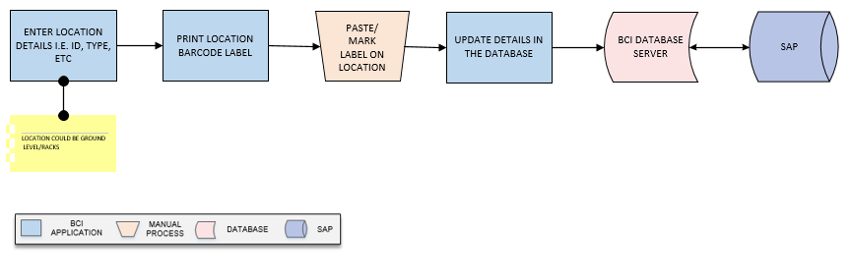
Activities
Module Description | This module will be used to provide unique identification to the each locations of warehouse by printing serialized barcode labels for them.  This activity will be done using Web Application.

Pre-Conditions | - Location master should be available.  - Location details should be saved in Location master.

Process Steps | - Select Location Code from dropdown list.  - Corresponding Location details i.e. Location Type, Description, Zone, etc. will appear on screen.  *Location details will be fetched from Location Master.  - Print barcode labels against selected Location  - Paste labels on Location  - Update details in database.

Post-Conditions | - Printing details will get saved in the database.

Validations | - An alert should be displayed in case Location Codes are not available in list.  - An alert should be displayed invalid Location Code is entered/ selected.  - An alert should be displayed in case Location details are not fetched from Location Master.

Bin Identification
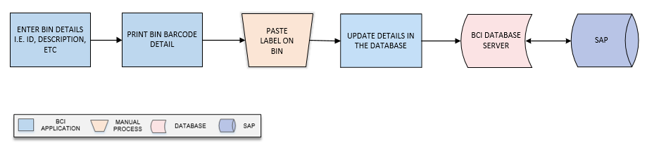
Activities
Module Description | This module will allow user to generate Barcode Label for Bins in order to provide unique identification and update Bin label printing detail in the database.

Pre-Conditions | - Bin master should be available.  - Bin details should be saved in Bin master.

Process Steps | - Select Bin ID from dropdown list.  - Corresponding Location details i.e. Active status, Description, etc. will appear on screen.  *Bin details will be fetched from Location Master.  - Print barcode labels against selected Bin.  - Paste labels on Bin.  - Update details in database.

Post-Conditions | - Printing details will get saved in the database.

Validations | - An alert should be displayed in case Bin IDs are not available in list.  - An alert should be displayed invalid Bin ID is entered/ selected.  - An alert should be displayed in case Bin details are not fetched from Bin Master.

Machine Identification
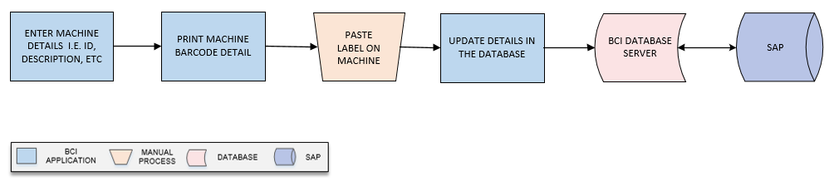
Activities
Module Description | This module will allow user to generate Barcode Label for each Machine in order to provide unique identification and update label printing details in the database.

Pre-Conditions | - Machine master should be available.  - Machine details should be saved in Machine master.

Process Steps | - Select Machine Code from dropdown list.  - Corresponding Machine details i.e. Active status, Description, Type, Remark, etc. will appear on screen.  *Bin details will be fetched from Location Master.  - Print barcode labels against selected Machine.  - Paste labels on Machine.  - Update details in database.

Post-Conditions | - Printing details will get saved in the database.

Validations | - An alert should be displayed in case duplicate Machine data is entered.  - An alert should be displayed in case Machine details are not received from SAP.  - An alert should be displayed in case Machine Barcode label is not printed

Pallet Identification
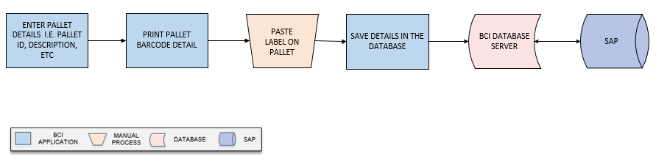
Activities
Module Description | This module will allow user to generate Barcode Label for each Pallet in order to provide unique identification and update label printing details in the database.

Pre-Conditions | - Pallet master should be available.  - Pallet details should be saved in Pallet master.

Process Steps | - Select Pallet ID from dropdown list.  - Corresponding Pallet details i.e. Active status, Description, Capacity, etc. will appear on screen.  *Pallet details will be fetched from Location Master.  - Print barcode labels against selected Pallet.  - Paste labels on Pallet.  - Update details in database.

Post-Conditions | - Printing details will get saved in the database.

Validations | - An alert should be displayed in case duplicate Pallet data is entered.  - An alert should be displayed in case Pallet details are not received from SAP.  - An alert should be displayed in case Pallet Barcode label is not printed

Inventory Replenishment (Bin – Component Mapping)
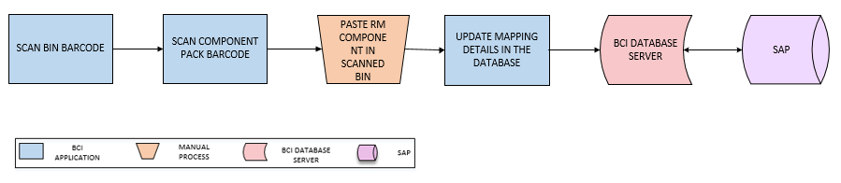
Activities
Module Description | This module will be used to map RM Components with the Bins and details are saved in database. This will help in validating data at the time of Bin issuance to Shop Floor.  Components could be MSL Components.

Pre-Conditions | - Bin master should be available.  - RM component should be available.

Process Steps | - Scan Bin Barcode Label.  - Scan Component Pack Barcode Label.  - User will place Component pack in scanned Bin.  - Update Bin – Component mapping details in the database.

Post-Conditions | - Mapping details will get displayed in the database.

Validations | - An alert should be displayed in case duplicate Bin data is updated.  - An alert should be displayed in case details are not received from SAP.  - An alert should be displayed in case Bin Barcode label is not printed.

Stencil Inventory
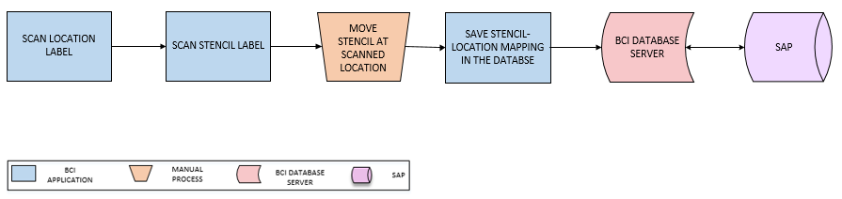
Activities
Module Description | This module will help user in keep track and record the Stencil used for Solder Paste Printing process. Stencil will be mapped with a storage location to keep record of the Stencil inventory.

Pre-Conditions | - Storage Location master should be available

Process Steps | - Scan Location Label  - Scan Stencil Label.  - Move/ store stencil at scanned location  - Update Stencil – Location mapping detail in the database.

Post-Conditions | - Stencil mapping location will get displayed in the database.

Validations | - An alert should be displayed in case duplicate location data is updated.  - An alert should be displayed in case details are not received from SAP.  - An alert should be displayed in case Stencil label is not printed.

FG Warehouse Operation

Receiving
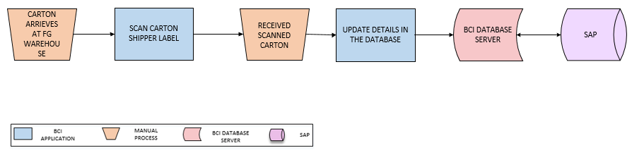
Activities
Module Description | This module will let user to scan & receive Carton from Shop Floor. The inventory details will be updated in the database.

Pre-Conditions | - FG cartons shall be received at FG warehouse.  - Carton Shipper label should be present.  - Pallet shall be available for palletizing cartons.  - All Cartons shall have barcode labels pasted on it.

Process Steps | - Cartons will arrive at FG Warehouse.  - User will scan Carton Shipper Label  - Carton details will be verified and same will be received.  - Update details in the database.

Post-Conditions | - Item Category shall be mapped with Pallet ID.  - Same Item Category Cartons shall be placed on same Pallet.  - Putaway of Pallets should be done.

Validations | - An alert should be displayed in case duplicate/ invalid barcode label is scanned.  - An alert should be displayed in case of invalid activity.  - System shall generate temporary Pallet ID in case Pallet has no barcode label.  - System shall map Pallet ID with item Category of scanned Cartons being placed on it.  - System shall display error message in case different Category Items are being placed on single Pallet.

Putaway
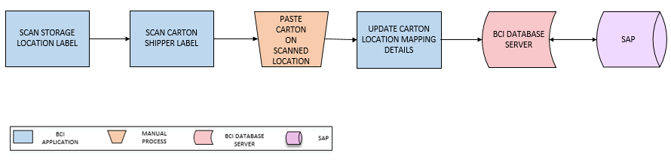
Activities
Module Description | The module will be used to place the FG Cartons on storage location suggested by system based on Location Capacity, Category and Type and to update the Location-Carton mapping details in database.

Pre-Conditions | - Location Label should be printed using the Location Master and tagged.  - Location Code and Location Type should be defined.  - Cartons should have barcode labels.  - Cartons shall be received on pallet.

Process Steps | - User will scan Location and Carton Shipper Label using HHT.  *Location could be Ground level/ Racks.  - User will place the Carton at scanned Location.  - Location – Carton mapping details will be updated in the database.

Post-Conditions | - Location-Cartons mapping will be stored in database.

Validations | - An alert should be displayed in case user scan other location than defined or suggested Location.  - An alert should be displayed in case duplicate / invalid barcode label is scanned  - System shall allow scanning of carton label for putaway in case Pallet Label is available

Picklist Generation
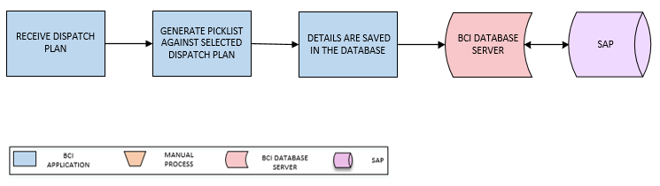
Activities
Module Description | In this process, Picklist will be generated against Dispatch Plan and a unique Picklist ID will be returned. The Dispatch Plan will be fetched from SAP.

Pre-Conditions | - Sales Order shall be received from SAP  - SMTP Host and Server details are required for email configuration  - Route master should be available

Process Steps | - Select Dispatch Plan.  *Dispatch Plan will be received from SAP.  - Generate Picklist against selected Dispatch Plan.  - Update corresponding details in the database

Post-Conditions | - Picklist Number is generated by System

Validations | - An alert should be displayed in case Stock quantity is not available  - An alert should be displayed in case of invalid activity  - System shall check the Stock Quantity against Sales Order Quantity  - System shall allow user to enter more quantity than mentioned in Sales Order for dispatch  - System will not allow user to enter more quantity than Stock available quantity  - System shall generate unique Picklist ID/ Number
Data Required from Microtek | - GET_API will be required to fetch/ pull Dispatch Plan details from SAP and same will be provided by Microtek.

FG Picking
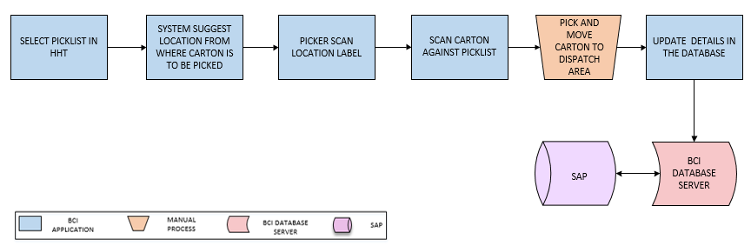
Activities
Module Description | In this process, requested Carton will be picked from the locations suggested by the system. System will verify the Carton against Picklist and details for the same will be updated in database.

Pre-Conditions | - Sales Order shall be received from SAP  - SMTP Host and Server details are required for email configuration  - Route master should be available

Process Steps | - User will select Picklist in HHT.  - System will suggest user about Location from where Carton is to be picked.  - Scan Location Barcode Label against Picklist  - Scan Carton Barcode Label against Picklist.  - User will pick Carton from scanned Location.  - Once picked, warehouse inventory will be updated.

Post-Conditions | - Route is created for Picking

Validations | - System will allow to print Route for material picking  - Single Picklist can be generated for single Sales Order or multiple Sales Orders

FG Dispatch
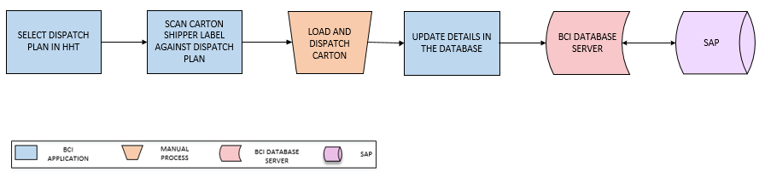
Activities
Module Description | In this process, Carton will be scanned and dispatched against Dispatch Plan and details for the same will get updated in database.

Pre-Conditions | - Picklist should be available.  - Picking should be complete.

Process Steps | - Select Dispatch Plan in HHT.  - Scan Carton Shipper Label.  - User will load and dispatch scanned Carton.  - Update dispatch details in the database.

Post-Conditions | - Transaction details are saved in database.  - Dispatch details shall be posted to SAP.

Validations | - An alert should be displayed in case duplicate/ invalid carton is scanned.  - Once loading is complete, system shall update the Sales Order Status as ‘Dispatched’.
Label Design | Sample Barcode label design for FG operation is given below:  